Dale Smallwood 130089872

Critical evaluation of the impact of social media

Contents

Table of Figures 3

Introduction 4

The first online advertisement 5

Facebook 6

Advertising cost on Facebook 6

Strengths of Facebook advertisements 7

The drawbacks of advertising on Facebook 7

Tik-Tok 8

The impact of influencers, could they be the next form of advertising? 8

The pros and cons of advertising on Tik-Tok 9

Reaching out to a large target audience 9

Communication between the consumer and the company 9

Brand recognition 10

Advertising strategy 10

Conclusion 11

Bibliography 12

Appendix 14

# Table of Figures

Figure 1 Here’s what the first banner ad looked like (HotWired / AT&T) (LaFrance, 2017) 14

Figure 2 Facebook Ad Centre 14

Figure 3 : Influencing the purchasing behaviour by influencers (Zdenka KÁDEKOVÁ, 2018) 15

Figure 4 TikTok display and hashtag view count (TikTok, 2021) 16

Figure 5 TikTok hashtag list related to trend (TikTok, 2021) 17

Figure 6 Projectxyz store layout (Projectxyz, 2021) 18

# Introduction

Inside this document is a critical evaluation of how advertisements on social media can impact on the business known as Projectxyz. The key points discussed are the strengths and weaknesses of advertising online, comparing social media platform’s ability to display adverts and how effective they are on the platforms.

## The first online advertisement

The first online advertisement was debuted on the 27th of October 1994. This was displayed as a banner (Figure1) for the company AT&T on a domain that is now known as Wired.com.

(LaFrance, 2017)“The ad set off a chain reaction that altered the course of the advertising industry” now the way advertisements are displayed to the consumer, have adapted over the years into many formats such as videos, GIFs, and pictures. The initial design of online advertisements (IAS team, 2017)“showed marketers where their audiences clicked and how they behaved”. According to (McCambley, 2013) and (LaFrance, 2017) this advertisement in particular had remained active for over four months and 44% of users, who had seen the advert had clicked it. But now the way data is handled grants the ability for marketers to be able to identify a vast extended amount of information such as the time the user is active on social media and what their interests are.

# Facebook

Facebooks current target audience is 25-34-year-olds. The website displays in a blog-like format, where users can post in different formats such as text, video, or images. Between posts while scrolling or when viewing videos, advertisements are displayed to the user. Facebook has evolved over the years with major updates, adding the ability for users to live stream and a system for a marketplace. On Facebook marketplace, users can sell products, granting more reasons to use the platform. Also on Facebook, businesses are able to upload advertisements onto the system. The way this is achieved is by using an (Facebook Business, 2021)“auction system” where the business is charged a fee, depending on how many users react or click on the advertisement.

## Advertising cost on Facebook

The cost of advertising on Facebook is very flexible and efficient. This depends on the businesses personal preference, (Facebook Business, 2021)“the budget you set for Facebook ads isn't necessarily the actual amount of money you spend. Your budget is spent over a given time period based on the budgeting option you've selected.” Therefore, if the advertisement was unsuccessful and had not gained a lot of interactions over any given day, the budget would be carried over to the next time the advert is deployed. There are two budgets that can be selected when using Facebook advertisement system. The first option is having a daily budget which limits the amount of money the company advertising is willing to be spent per day, which could help with gaining too much traffic and orders. The company could supply or could be used for a special discount, for example the first fifty users that click the advert, gain free delivery on their order. Once this daily target is met, the advertisement would not be displayed until the next runtime of that advertisement. The second option would be a lifetime budget / total budget. The reason to use this option is to not exceed the amount the company advertising is willing to spend and to let as many consumers interact with the advertisement as quickly as possible.

### Strengths of Facebook advertisements

A major positive is that Facebook users are able to share information and advertisements with ease and post it onto their personal wall, where the user’s friends and family are able to see. As well spreading the advertisement by word of mouth as (Prasad, Gupta, & Totala, 2017) have shown “Social media usage and electronic word of mouth have positive impact on purchase decision”. The impact of this would be displayed on the analytics breakdown shown in (Figure2), stating the number of reactions and clicks the advert has gained. This is displayed in a simplistic way for users to understand.

### The drawbacks of advertising on Facebook

One of the key drawbacks of advertising on Facebook is that users have the ability to hide advertisements from your business if they are not interested in the advertisement shown to them. Users can post irrelevant information or create fake negative reviews of the product in the comments section of the post. The comment can be removed via reporting but normally the process can take too long and could theoretically tarnish the company. Another issue would be that with too many competitors and repetitive advertisement styles could lead to consumers losing interest.

# Tik-Tok

Tik-Tok draws a large number of users, that progressively rises the platform's impact, and then draws other businesses to post advertisements on the platform in order to make large profits. (Yuan Weilin, 2020). The average age gap for Tik-Tok’s targeted audience is people between 19-35 years old (Yuan Weilin, 2020) as (Zdenka KÁDEKOVÁ, 2018) has stated in their studies (Figure3) they have found out of across both gen y and gen z 459 users, 41% of them regularly and 32% sometimes follow the recommendations of an influencer this has also been proven multiple times with trends and previous marketing attempts.

## The impact of influencers, could they be the next form of advertising?

When executed properly, influencer marketing can be extremely beneficial. Gucci utilized influencer marketing to promote their new perfume brand, Gucci Bloom, in 2019. They partnered with 23 Instagram artists to produce extremely imaginative material inspired by the flowery environment around the scent. With 135 pieces of content generated and almost 750,000 followers, the campaign was able to raise substantial awareness. Some of the produced media was even included on Gucci's official Facebook Page. (Michael Haenlein, 2020) Therefore, paying an influencer to advertise the product to their viewers on different social media platforms they may frequently use and have a large following on.

This could be a viable solution if the targeting audience is relevant. Another way influencers could impact the decision would be by creating product review videos. Some influencers exclusively create these which receive lots of views. Frequently, alongside this there is an ongoing trend and hashtag called ‘#TikTokMadeMeBuyIt’. In (Figure4) the layout of Tik-Tok is shown this also displays that currently there are 5.6billon views of topic. The topic is that popular there is also secondary hashtags branching out to different product types shown in (Figure5).

## The pros and cons of advertising on Tik-Tok

Advertisements are easily skippable by moving your finger, but this is combated by having short engaging content. This content typically lasts between 30 seconds to 3 minutes. Sometimes the advertisements are produced by content creators but sponsored by a company leading to a product placement with the consumers favourite influencer which makes the video feel like less of a chore and more interesting.

## Reaching out to a large target audience

As Projectxyz has displayed on their website, they supply many different categories of E-books (Figure6). This grants a versatile target audience. Currently Projectxyz has no social media presence or advertisements online. There sales could be improved upon using advertisements displayed on Facebook or Tik-Tok using there add manger system as they use analytics to calculate when and who to display the advertisement too. This method has been successful numerous times such as Lancaster university used Tik-Tok to promote their online open day. (Prill, 2021) “By using In-Feed Ads, and on a tight budget, the university achieved 9 million engagements and over 90k clicks.”

## Communication between the consumer and the company

If Projectxyz chooses to display advertisements on social-media users sometimes have ability to comment on the post either by leaving reviews or general enquires this is displayed publicly therefore Projectxyz would need to respond frequently to maintain a professional marketing campaign. As (Tobias Lohse, 2017) has stated in their studies “our results show that positive (Online customer reviews) OCRs can lead to lower return rates, higher sales after returns, and better conversion rates.” A downside would be that the consumer can leave negative reviews or issues with the product which could lead to a decrease in sales.

# Brand recognition

In a study conducted by (Siti Maria, 2019), after gathering information from 50 individuals it was discovered that, the correlation between social media marketing and advertising produces a beneficial impact on brand awareness. Inside the same study it was proven that brand recognition and the effectiveness of advertising has a direct positive impact on consumer purchase decisions.

## Advertising strategy

Although applying the practices above is necessary, the most important practice maintaining a strategy and keeping consistent schedule. In (Tobias Lohse, 2017) studies after researching six food and drinks products they have found that, increasing a brand's popularity by posting during peak hours on a weekday is more effective than posting during non-peak hours on weekends and passive brand communication is less effective than active brand communication in terms of building brand awareness.

## Conclusion

From the information gathered, it is suggested that depending on the TA the method of advertisements is displayed should be altered. If the TA is bellow twenty-four Projectxyz should seek out an influencer to promote the products on their platform either inside a product review video or relevant influencer related to the product. It is also recommended to create their own company profile on social media and communicate frequently with users aiding them with issues or general enquires alongside posting updates about the products regally to maintain an interest in the brand although it’s not guaranteed advertising online has a chance in increasing the annual revenue and granting the opportunity for further expansion.

# Bibliography

Facebook Business. (2021). *How ad billing works on Facebook*. Retrieved September 28th, 2021, from Facebook for business: https://www.facebook.com/business/help/716180208457684?id=1792465934137726

IAS team. (2017, December 19th). *The evolution of social media advertising*. Retrieved September 27th, 2021, from IAS Integral Ad Science: https://integralads.com/uk/insider/evolution-of-social-ads/

LaFrance, A. (2017, April 21st). *The First-Ever Banner Ad on the Web*. Retrieved september 27th, 2021, from The atlantic: https://www.theatlantic.com/technology/archive/2017/04/the-first-ever-banner-ad-on-the-web/523728/

McCambley, J. (2013, December 12th). *the first ever banner ad: why did it work so well?* Retrieved September 27th, 2021, from the guardian: https://www.theguardian.com/media-network/media-network-blog/2013/dec/12/first-ever-banner-ad-advertising

Michael Haenlein, E. A. (2020). *Navigating the New Era of Influencer Marketing: How to be Successful on Instagram, TikTok, & Co.* Paris: Sage journals. doi:10.1177/0008125620958166

Prasad, S., Gupta, I. C., & Totala, N. K. (2017). *Social Media Usage, Electronic Word of Mouth and Purchase Decision Involvement.* Emerald Publishing Limited. doi:10.1108/APJBA-06-2016-0063

Prill, C. (2021, May 21st). *Lancaster University case study.* Retrieved October 18th, 2021, from TikTok for business: https://www.tiktokforbusinesseurope.com/inspiration/lancaster-university

Projectxyz. (2021, october 11th). *Projectxyz product category*. Retrieved October 11th, 2021, from Projectxyz: https://www.projectxyz.co.uk/product-category/ebooks/

TikTok. (2021, october 11th). *Search result*. Retrieved october 11th, 2021, from TikTok: https://www.tiktok.com/tag/Tiktokmademebuyit?lang=en

Tobias Lohse, J. K. (2017). *HOW ONLINE CUSTOMER REVIEWSAFFECT SALES AND RETURN BEHAVIOR –AN EMPIRICAL ANALYSIS IN FASHION E-COMMERCE.* Germany: AIS Electronic Library (AISeL). doi:ISBN 978-0-9915567-0-0

Tri Hanifawati, U. S. (2019). *MANAGING BRANDS’ POPULARITY ON FACEBOOK: POST TIME, CONTENT, AND BRAND COMMUNICATION STRATEGIES.* Universitas Gadjah Mada: Core. doi:10.22146/jieb.45755 ISSN: 2085-8272

Yuan Weilin, M. y. (2020). *Research on the International Marketing Strategy of Tik Tok--Based on the Analysis of 4P Theory.* China: Francis Academic Press. doi:10.25236/FER.2020.031423

Zdenka KÁDEKOVÁ, M. H. (2018). *influencer marketing as a modern phenomenon creating a new frontier of virtual opportunties.* Slovak Republic: Communication Today. Retrieved September 25th, 2021, from https://www.communicationtoday.sk/download/22018/06.-KADEKOVA-HOLIENCINOVA-%25E2%2580%2593-CT-2-2018.pdf

]

# Appendix



Figure 1 Here’s what the first banner ad looked like (HotWired / AT&T) (LaFrance, 2017)

Figure Facebook Ad Centre

Figure 3 : Influencing the purchasing behaviour by influencers (Zdenka KÁDEKOVÁ, 2018)

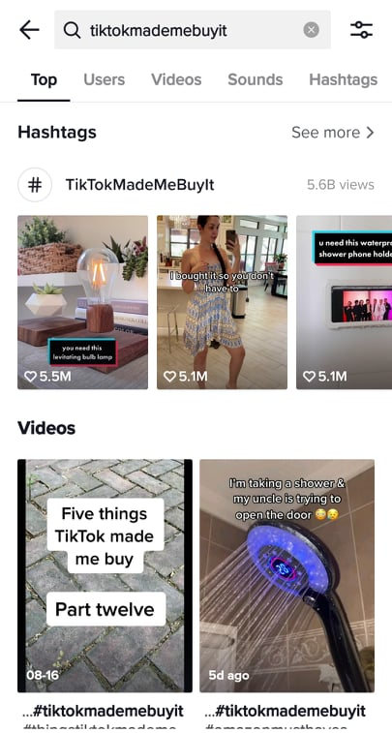

Figure TikTok display and hashtag view count (TikTok, 2021)

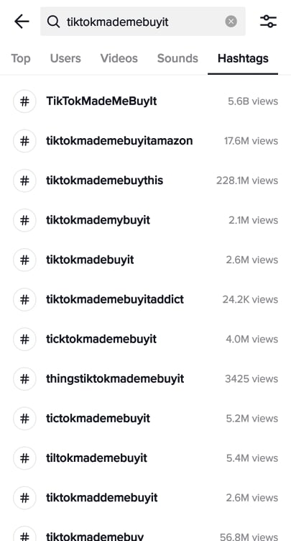

Figure TikTok hashtag list related to trend (TikTok, 2021)

Figure Projectxyz store layout (Projectxyz, 2021)